[ Insert official UPAEP logo ]
UPAEP · Decanato de Ingenierías
EVIDENCE — US01C-T4
Test invalid credentials and unauthorized access
SmartGreenAI: Cilantro Crop

1. Task information
Task ID | US01C-T4
User Story | US-01-C — Complete secure login and role-based access
Sprint | Sprint 2 (2026-09-21 – 2026-10-09)
Week | Week 1
Responsible | Alexis Enrique Valle Parra
Peer reviewer | Jorge Velez Delgado
Planned / actual hours | 1 h / 1 h
Completed on | September 25, 2026
Status | Done

2. Task description
Test wrong password, non-existent user, empty fields, expired session and typing a restricted URL directly without logging in. Error messages must not reveal whether the user exists.

3. Completion conditions
✓ Condition 1: Wrong password, unknown user, empty fields, expired session and direct URL cases were executed.
How it was verified: The five negative cases were executed in the browser and against the API: wrong password, non-existent user, empty fields, expired session and a restricted URL typed without logging in.
API responses of the negative cases (attached: US01C-T4_Test_Invalid_Credentials_Unauthorized_Access_6.txt)
POST /api/auth/login
{
"email": "producer@smartgreen.ai",
"password": "********"
}
→ HTTP 401 Unauthorized (19 ms)
{
"status": 401,
"code": "ERR_AUTH_REQUIRED",
"message": "Invalid credentials.",
"details": []
}
POST /api/auth/login
{
"email": "nobody@smartgreen.ai",
"password": "********"
}
→ HTTP 401 Unauthorized (12 ms)
{
"status": 401,
"code": "ERR_AUTH_REQUIRED",
"message": "Invalid credentials.",
"details": []
}
POST /api/auth/login
{
"email": "",
"password": "********"
}
→ HTTP 400 Bad Request (7 ms)
{
"status": 400,
"code": "ERR_VALIDATION_FAILED",
"message": "The submitted data does not match the required schema.",
"details": [
{
"field": "email",
"issue": "Email or username is required."
},
{
… (5 more lines in the attached file)
GET /api/measurements/latest
Authorization: Bearer eyJhbG…
→ HTTP 401 Unauthorized (5 ms)
{
"status": 401,
"code": "ERR_AUTH_REQUIRED",
"message": "The session has expired. Please sign in again.",
"details": []
}
GET /api/devices
→ HTTP 401 Unauthorized (5 ms)
{
"status": 401,
"code": "ERR_AUTH_REQUIRED",
"message": "A Bearer token is required. Sign in to obtain one.",
"details": []
}

✓ Condition 2: All attempts are rejected with a generic error message.
How it was verified: All attempts are rejected. The wrong-password and unknown-user cases return the identical message "✖ Invalid credentials." (HTTP 401 ERR_AUTH_REQUIRED), so the system never reveals whether an account exists; the password is checked against a dummy bcrypt hash when the user is unknown so the response time does not reveal it either.
server/src/modules/auth/service.js — lines 20–41
const GENERIC = 'Invalid credentials.';
const user = await db.one(
`SELECT u.id, u.email, u.username, u.full_name, u.password_hash,
u.is_active, u.organization_id, u.role_id, r.name AS role_name
FROM users u
JOIN roles r ON r.id = u.role_id
WHERE lower(u.email) = lower($1) OR lower(u.username) = lower($1)`,
[email],
);
// Compare against a dummy hash when the user does not exist so the response
// time does not betray which emails are registered.
const hash = user ? user.password_hash : '$2a$10$invalidinvalidinvalidinvalidinvalidinvalidinvalidinvalidinv';
const passwordMatches = await bcrypt.compare(password, hash);
if (!user || !passwordMatches || !user.is_active) {
throw unauthorized(GENERIC);
}
await db.query('UPDATE users SET last_login = NOW() WHERE id = $1', [user.id]);

✓ Condition 3: Screenshots saved in the evidence folder.
How it was verified: A screenshot of every case was saved in the evidence folder (Figures 1–5).
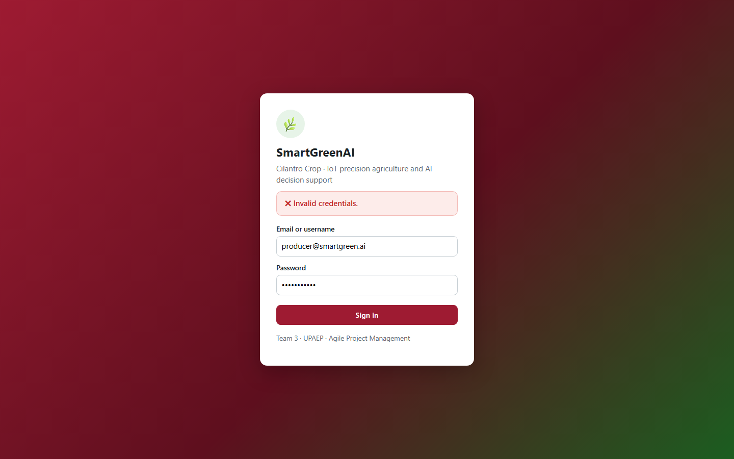
Figure US01C-T4-1. Wrong password: the form shows "✖ Invalid credentials." and stays on the login page. (US01C-T4_Test_Invalid_Credentials_Unauthorized_Access_1.png)
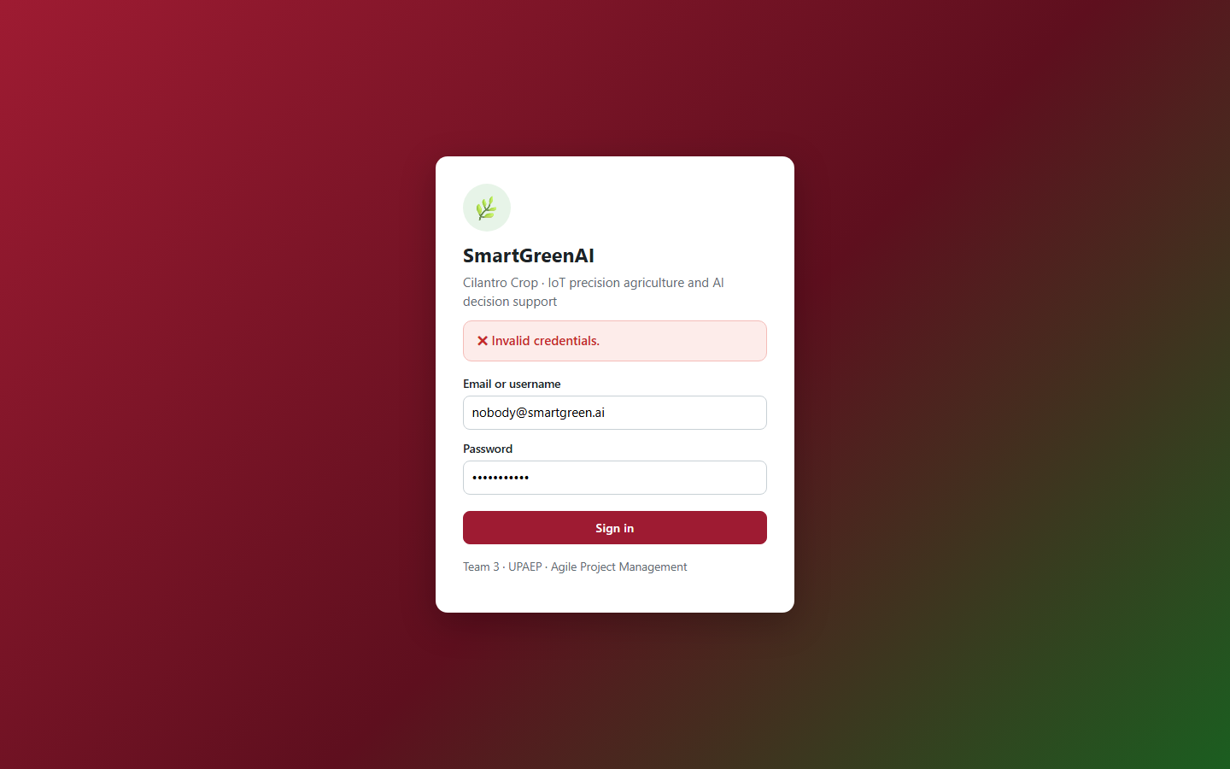
Figure US01C-T4-2. Non-existent user: the form shows "✖ Invalid credentials." and stays on the login page. (US01C-T4_Test_Invalid_Credentials_Unauthorized_Access_2.png)
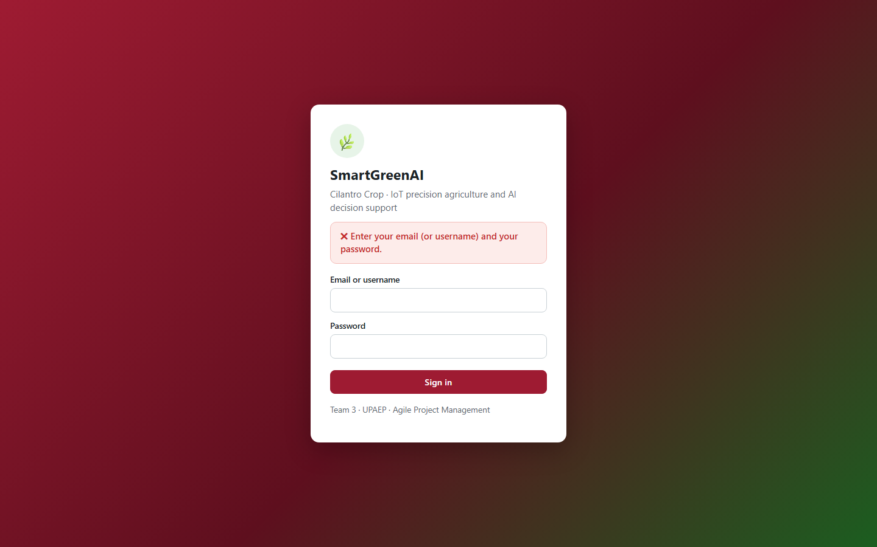
Figure US01C-T4-3. Empty fields: the form shows "✖ Enter your email (or username) and your password." and stays on the login page. (US01C-T4_Test_Invalid_Credentials_Unauthorized_Access_3.png)
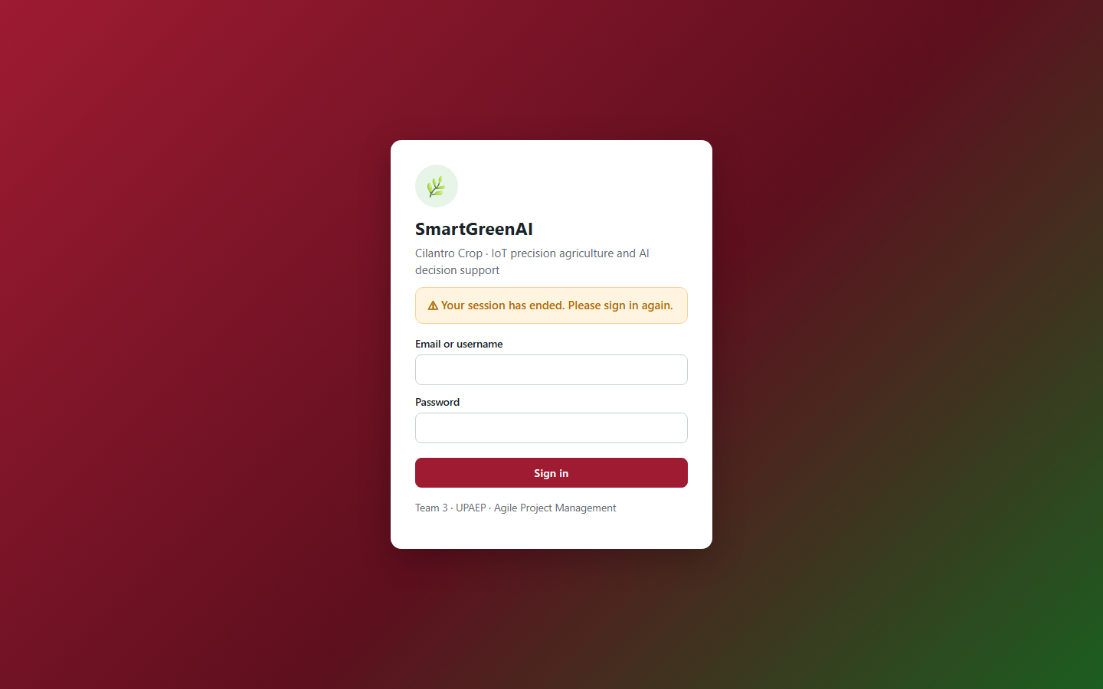
Figure US01C-T4-4. Expired session: the dashboard rejected the expired token and returned to the login page with "⚠ Your session has ended. Please sign in again.". (US01C-T4_Test_Invalid_Credentials_Unauthorized_Access_4.png)
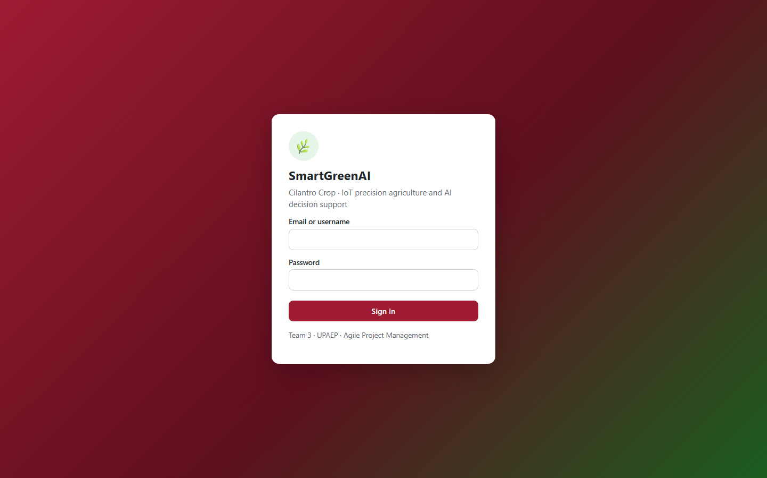
Figure US01C-T4-5. Restricted URL typed directly without logging in: redirected to the login page. (US01C-T4_Test_Invalid_Credentials_Unauthorized_Access_5.png)
✓ Condition 4: Evidence: Negative test cases documented with screenshots; all attempts are rejected.
How it was verified: The negative test cases are documented in the test table with their real results; every attempt was rejected.

4. Negative test cases
ID | Case | Steps | Input | Expected | Actual | Result
NEG-01 | Wrong password | Login form with a real email and a wrong password | producer@smartgreen.ai / WrongPass1! | Rejected, generic message | "✖ Invalid credentials." · API 401 ERR_AUTH_REQUIRED | PASS
NEG-02 | Non-existent user | Login form with an unknown email | nobody@smartgreen.ai | Rejected with the same message as NEG-01 | "✖ Invalid credentials." · API 401 | PASS
NEG-03 | Empty fields | Submit the empty form; API call with empty strings | "" / "" | Rejected before authentication | "✖ Enter your email (or username) and your password." · API 400 ERR_VALIDATION_FAILED | PASS
NEG-04 | Expired session | Open the dashboard with an expired token | JWT exp in the past | Session rejected, back to login | "⚠ Your session has ended. Please sign in again." · API 401 "The session has expired. Please sign in again." | PASS
NEG-05 | Direct URL without login | Type /admin/devices.html in a new browser | no session | Redirect to login; API 401 | redirected to login · API 401 ERR_AUTH_REQUIRED | PASS
Totals: 5 cases · 5 PASS · 0 FAIL

5. Attached files
- US01C-T4_Test_Invalid_Credentials_Unauthorized_Access_1.png
- US01C-T4_Test_Invalid_Credentials_Unauthorized_Access_2.png
- US01C-T4_Test_Invalid_Credentials_Unauthorized_Access_3.png
- US01C-T4_Test_Invalid_Credentials_Unauthorized_Access_4.png
- US01C-T4_Test_Invalid_Credentials_Unauthorized_Access_5.png
- US01C-T4_Test_Invalid_Credentials_Unauthorized_Access_6.txt

6. Traceability
Related requirements | FR-01, FR-02, FR-03, NFR-03, NFR-04
Implementation | See docs/TRACEABILITY.md
Verification | See docs/TRACEABILITY.md

7. Sign-off
Role | Name | Date | Signature
Responsible | Alexis Enrique Valle Parra | September 25, 2026
Peer reviewer | Jorge Velez Delgado | September 25, 2026
Product Owner acceptance | Alexis Enrique Valle Parra | September 25, 2026

